January 2015

Educational Document: eDoc080006(DMS)Jan2015

Designing Master Key Systems

For ASSA ABLOY Door Security Solutions Key Systems Specialists.

Master keying establishes the security for a facility, not just the pining requirements of a cylinder. It determines the level of access that will be granted to employees, service personnel, and the general public.

Until just a few years ago master keying used to be the sole locking provision for the building owner, today it’s only part of an integrated locking system. Today the building owner is looking for solutions and is looking for someone to assist them in determining what the best locking system would be for their facility.

Through a survey of Facilities Managers and Security directors across the country it was clearly noted that nobody asked them what their keying needs were when an addition was being added, or a new facility was being planned.

Key systems will always be required for buildings and/or facilities for a long time, and based on the functionality of the building or facility and the security objectives the structure of the master key system will vary.

To begin the process of designing a master key system it’s important to gather as much background information as possible on the physical layout of the structure or buildings; this can be done by asking for a copy of the facilities site plan showing all of the buildings and their locations. If there is no formal site plan you can continue by preparing a sketch, simply draw a series of blocks on a sheet of paper representing each building and its location.

For new systems determine the size and scope of the facility. For a single building list the total number of keyed openings, if it’s a multi-story building indicate the number of floors, plus the number of keyed openings. For multiple building complexes mark the identity (name or building number) of all the buildings shown on the site plan or sketch, list the number of floors, and the total number of keyed openings, then define any commonalities in keying conditions between buildings.

If it’s an existing system where the owner wants to add to it; questions like, is there a schematic describing the structure of the existing key system(s) available? Is there a listing (bitting list) of all key bittings in the system? If there is a schematic does it contain the key combinations currently in use and does it indicate any key combinations available for future use? If cross keying exists how well is it documented? Additional questions should be asked like; is there an inventory listing of keyed doors and does the list include each doors identity, location, and how it’s keyed? Another question that should be asked; are there other key systems in use and if so where are they?

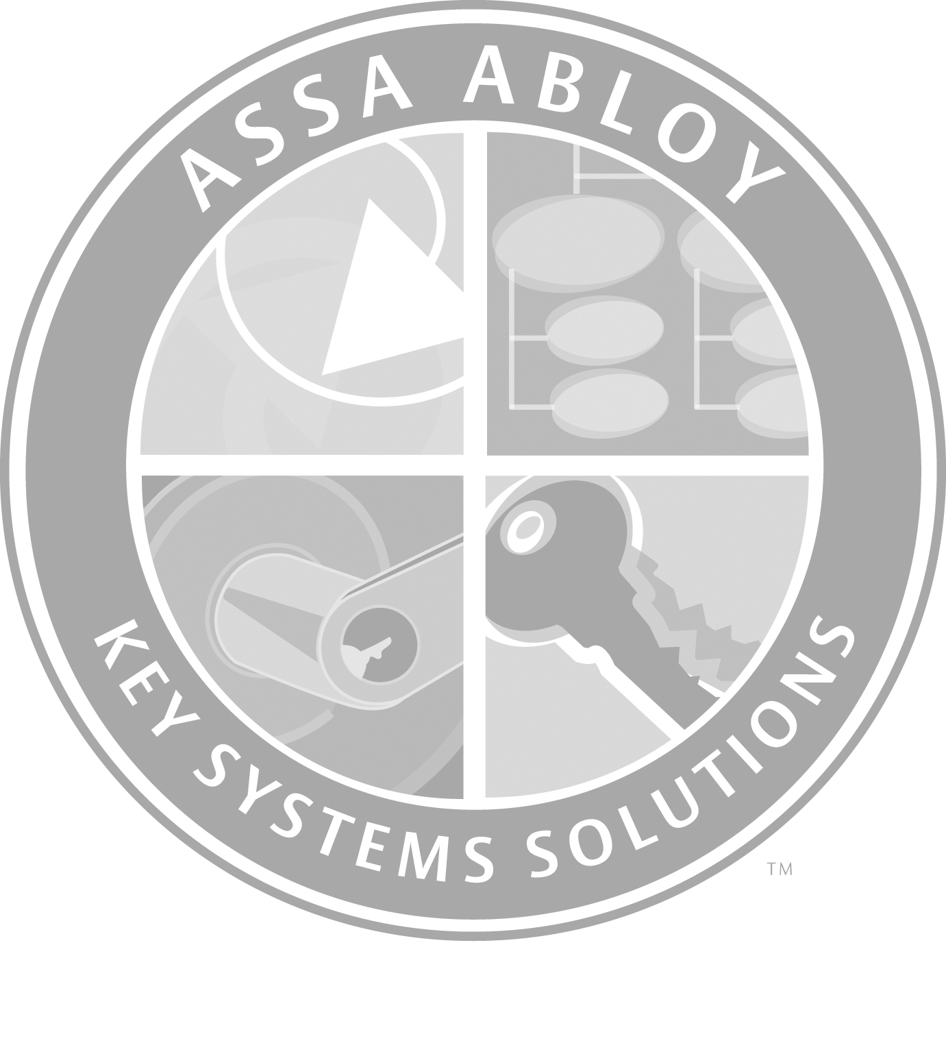

Once it’s been determined that it is going to be a new master key system or one that is keyed into an existing system it will be important to identify the security objective for each door receiving a cylinder.

SECURITY OBJECTIVES
1
- To determine the security objective the door’s vulnerability to certain risks will have to assess.
First and foremost, occupants today want to be assured that while they are in a building, their safety has been provided for. The more clearly the building’s security objectives are defined the more thoroughly you can determine ways to meet those objectives. From the outset you must also be aware that different parts of a facility can have different security objectives.

- Security objectives can be broken down in to six separate categories.

Authorized Access: The highest level of security- authorized access to a specified area only to selected individuals. Access is granted only to those individuals who have the proper identification and who have been issued a key, token or access card. Such an area can be as small as a closet or a room, or it can encompass a full building.

Key Control: A complete and accurate accounting of all keys within a system. Maintaining such control is recognized as one of the most important elements within a secured locking system.

User Friendly: The most common and accessible locking device which does not require any special knowledge to gain access when locked. Key blanks and locking components are readily available through all distribution channels.

Serviceable: Service to the locking component is accomplished by individuals with locksmithing skills. Service does not require an alarm license or any electrical knowledge.

Audit Trails: Confirmed usage of all transactions. Each time access to a secured area is granted or denied, it is documented.

Time Zones: Time limited access. Access into designated areas is allowed during specific times only.

The overall objective when designing a master key system is to provide the highest level of security possible and allow each department to function smoothly while considering traffic flow throughout the facility. That means you must determine the correct level of access for each door and this can be done by identifying the relationship of each department to the overall security plan of the entire facility or building.

SEPARATING DEPARTMENTS & BUILDING SECTORS
2
- Here are a few examples of the most common departments and/or building sectors, and suggestions as to how they could be keyed and important questions to be asked.
Perimeter. Traditionally, the “building envelope” includes all exterior doors, roof surfaces, gates and adjacent buildings; therefore, it will be critical that the selected locking device incorporates the right cylinder mechanism which supports the chosen security objective.

Perimeter cont.
☞
Building entry and exit doors; could be keyed alike by building, or all keyed alike through out the entire building or complex. If the facility is a public building such as a school that allows the general public to use spaces for meetings or gatherings it may by wise to identify and key one of the perimeter doors in the building(s) to an additional key combination for use by the public. This would restrict their access to only that entry door opening during off-hours.
Other openings to be considered would be roof access areas, basement sub level doors, tenant spaces, service area spaces, receiving/shipping dock doors, perimeter fence and gates.
☞
Identify those doors that will have intelligent type locking devices that will tie into an access control system, verify if the they have a mechanical cylinder override?
☞
The Cylinders/Cores used in this type condition should be keyed as an SKD set and not part of the facilities main master key system. The cylinder/cores purpose is to act as an over- ride to open the door in the event that the electronics fail.

Core Areas (Operations). Sensitive areas that are crucial to the daily operations of the facility and/or building complex; also known as physical plant, the doors located in this sector are not normally accessed by the users or occupants of the building. Access to these areas should be restricted to in-house or contracted service personal. Examples,
    - Elevator machines rooms and access areas.
    - Data, electrical, mechanical, plumbing, janitor, H.V.A.C. closets and spaces.
    - Computer equipment closets.
      - These areas are becoming extremely critical in the over-all security demands of the facility.
    - Stair doors (if being secured)
    - Housekeeping/Linen,
    - Parking garage areas.
    - Any other common core or physical plant functions applications.
☞
There are two methods that can be used to define the keying structure for physical plant areas.
They could be keyed either as part of the facilities primary master key system, or they could be keyed to a separate physical plant master key system. In some instances facilities have created a “Physical Plant” Master key system separate from the facilities main master key system. This key system controls all the general maintenance and mechanical spaces scattered through the complex.
While on the surface this may seem an inconvenience, with some thought and careful planning this approach has worked very well for most facilities who have adopted this concept. This method enables the maintenance and service people to be issued specific keys that allow them access to specific areas where needed. The Maintenance supervisor can have a master level key that gives specific access to all these types of openings with a single key. The system isolates the physical plant spaces from the general occupants/tenants of a facility allowing access only to authorized personnel.

Management. Various departments that are also vital for daily business activity – primarily human resources, administration, information technology, executive offices, sales and finance. Since these areas frequently are visited by members of the public, internal integration with controlled access to the public is a must.

Management cont.
☞
It will be critical to have each department head/supervisor determine his/hers needs regarding who in their department requires a key to access their own space or a common space within the designated work area.
☞
One important question to ask is “does every employee require a key”?

Services. Areas that provide employees, visitors, students, faculty, and staff members a variety of services (restrooms, medical treatment areas, housekeeping, foodservice, retail space, etc.) while they are on the premises. While occupants expect convenient and easy access to these services, security must be ensured at all times.
☞
Depending on the service area and the relationship to the overall function of the facility it will be important to determine how this sector and/or personnel interacts with other sectors within the building and accommodations must be made to provide a smooth flow among all building occupancies with out jeopardizing the overall security objectives of the department.

Tenants. Temporary or non-permanent tenants of the building (retail spaces, office suites, restaurants, etc).
☞
It’s recommended to establish a separate system.

Special Applications. Doors requiring special consideration based on special function hardware and/or access control where key override is required, or any other special application. Some examples are double cylinder classroom function locksets, birthing/maternity areas, multipurpose rooms, dorm-room entry doors. Each has their own security needs.
For these applications it will be critical to understand the functionality of the opening and the intent of the special types of locking arrangements to ensure compatibility with the facilities overall security objectives.
☞
The ability to separate unique applications that require different security objectives and the awareness of who will access them will be important when selecting the appropriate locking device.

For each of these departments and/or building sectors, locking solutions can vary from mechanical cylinders to integrated electronics including intelligent locking devices.

LOCKING SEGMENTS
3
- Selecting the Appropriate Locking device. Since today’s security objectives require each department or building sector to have a unique responsibility it has become increasingly difficult to meet all of a building’s security needs with just one locking device. The selection of the right locking device can be made after the security objectives have been identified. Certain locking devices can meet more than one security objective, depending on the type of security required for each department or building sector.

- Locking devices are further broken down into specific locking segments for the purpose of choosing the correct option that best meets the chosen security objective. The different locking segments are;

Patented Locking System (PLS): The most secure mechanical cylinder and key. PLS incorporate a utility patented security feature that provides restricted access to system components through authorized distribution channels.

Authorized Access Control (AAC): The highest level of security for stand-alone locking devices. Authorizes access to selected individuals within specified time periods. Access is granted with a key, card or token. All usage transactions are confirmed & audited. Security is assured through authorized and certified distribution channels.

Integrated Electronics (IE): A centralized facilities-management system capable of managing security and access control functions for multiple doors. Electrical locking components interface with multidoor controllers and switches to meet the security and access control needs. Systems support and services require highly trained personnel, and maintenance usually requires an alarm & low voltage license.

Mechanical Cylinders (M): The most common type of cylinder, providing the lowest level of physical security. Requires a minimum of knowledge to re-key and service. Availability and access to service items is non-restrictive.

CONCLUSION

Communicating the master keying needs of a facility is critical. The industry standard symbols for master keying provide the necessary format when communicating to others. It identifies how the cylinder is to be pinned and how it fits within the overall master key system. It identifies the cylinder’s change key, the appropriate master key/s, top master keys and any special purpose key(s).

Although this standard has been around for more than 30 years, the ASSA ABLOY Key System Specialist must have a thorough understanding of it. It affects the accurate communication of the master keyed systems requirements to the manufacturer for order processing and to the building owner for implementation and control. The ASSA ABLOY Master Key System Design Guide was created to help in the planning and designing of a master key system. It takes you through the entire process including a glossary of master key system terms and worksheets to assist in the layout process.

Understanding what the building owner's needs are is simple – listening to what they are asking for becomes critical to the process.

ASSA ABLOY Key System Specialists must be able to tie these important elements together and design a secured master key system for any facility or building owner.

End

